

**King Abdullah II School of Engineering**

Embedded Systems Design

Design Project Titled:

**Robotic Hand Control System**

Student’s Names:

Reham Al-Shawawreh 20218172

Hebah Al-Tahhan 20218175

Instructor:

Dr. BelalSababh

**Table of Contents**

**Table of Figures** 3

**Abstract** 4

**Introduction and Background** 5

**Methodology** 6

**Required Components** 8

**1.** **HCS12 Microcontroller:** 8

**2.** **Motors:** 9

**3.** **Sensors:** 10

**4.** **Power Supply:** 11

**5.** **Glove:** 11

**6.** **Electrical equipment** 11

**7.** **Wiring and Connections:** 12

**8.** **Control Algorithm:** 12

**Programming Environment** 12

**3D Printing Design** 12

**Our Project module** 14

**Challenges** 14

**Future work** 15

**Conclusion** 15

**References** 16

# **Table of Figures**

Figure 1:Robotic hand 6

Figure 2:Block diagram of robotic hand controlled 7

Figure 3: Schematic for controlled robotic hand 7

Figure 4:HCS12 microcontroller 8

Figure 5:Servo motor 9

Figure 6:Angular rotation 9

Figure 7:Flex Sensor 10

Figure 8:Electrical equipment 11

Figure 9:3D Printer module 13

Figure 10:Robotic hand Project 14

# **Abstract**

This project presents the design and implementation of a robotic hand control system using the HCS12 microcontroller. The objective is to develop a robotic hand capable of mimicking human hand movements and performing gripping actions with precision. The HCS12 microcontroller serves as the central control unit, interfacing with motors, sensors, and a user interface. The control system incorporates motor control algorithms, sensor feedback, and a user-friendly interface to enable intuitive control of the robotic hand. The project involves hardware setup, motor control circuit design, sensor integration, algorithm development, and user interface design. Through this project, we aim to demonstrate the capabilities of the HCS12 microcontroller and explore its potential for controlling complex robotic systems.

The design and implementation of a gesture-control robotic hand using a flex sensor are proposed. The robotic hand is designed in such a way that it consists of four movable fingers. The robotic hand is made to imitate human hand movements using a hand glove. The hand glove consists of four flex sensors for controlling the finger movements. The actuators used for the robotic hand are servo motors. The finger movements are controlled using cables that act like the tendons of the human hand. A prototype of the robotic hand was constructed and tested for various hand movements.

# **Introduction and Background**

The field of robotics has made significant advancements in recent years, enabling the development of highly dexterous and capable robotic systems. Among these systems, robotic hands play a crucial role in mimicking human hand movements and performing intricate tasks with precision. To achieve such control, an efficient and reliable control system is essential. This report focuses on designing a control system to operate a robotic hand using an HCS12 microcontroller, which offers the necessary computational power and I/O capabilities for controlling complex robotic systems.

The robotic hand, with its multiple degrees of freedom, requires a sophisticated control system to translate desired motions into precise and coordinated movements. The HCS12 microcontroller is a powerful embedded platform that combines a 16-bit CPU, integrated peripherals, and a versatile architecture, making it an ideal choice for controlling robotic applications. By leveraging its capabilities, we can design a control system that effectively drives the robotic hand's actuators, processes sensor data, and achieves real-time control.

The control system's primary objective is to facilitate intuitive and accurate control of the robotic hand. This involves capturing input signals, such as desired joint positions or forces, and translating them into control signals that drive the hand's actuators. Additionally, the control system may incorporate feedback mechanisms to provide closed-loop control, allowing the hand to adapt and respond to changes in its environment.

To achieve successful control, the control system must also integrate sensor technologies that provide crucial information about the hand's position, force, and tactile feedback. These sensors, which could include flex sensors, force sensors, or tactile sensors, enable the microcontroller to gather real-time data about the hand's state and make informed decisions for precise control.

Furthermore, the design of the control system encompasses the development of software algorithms that process sensor data, generate control signals, and implement the desired control strategies. These algorithms can range from simple position control to more advanced force control or even motion planning algorithms for complex grasping tasks. The HCS12 microcontroller's computational capabilities allow the implementation of these algorithms in real-time, enabling responsive and accurate control of the robotic hand.

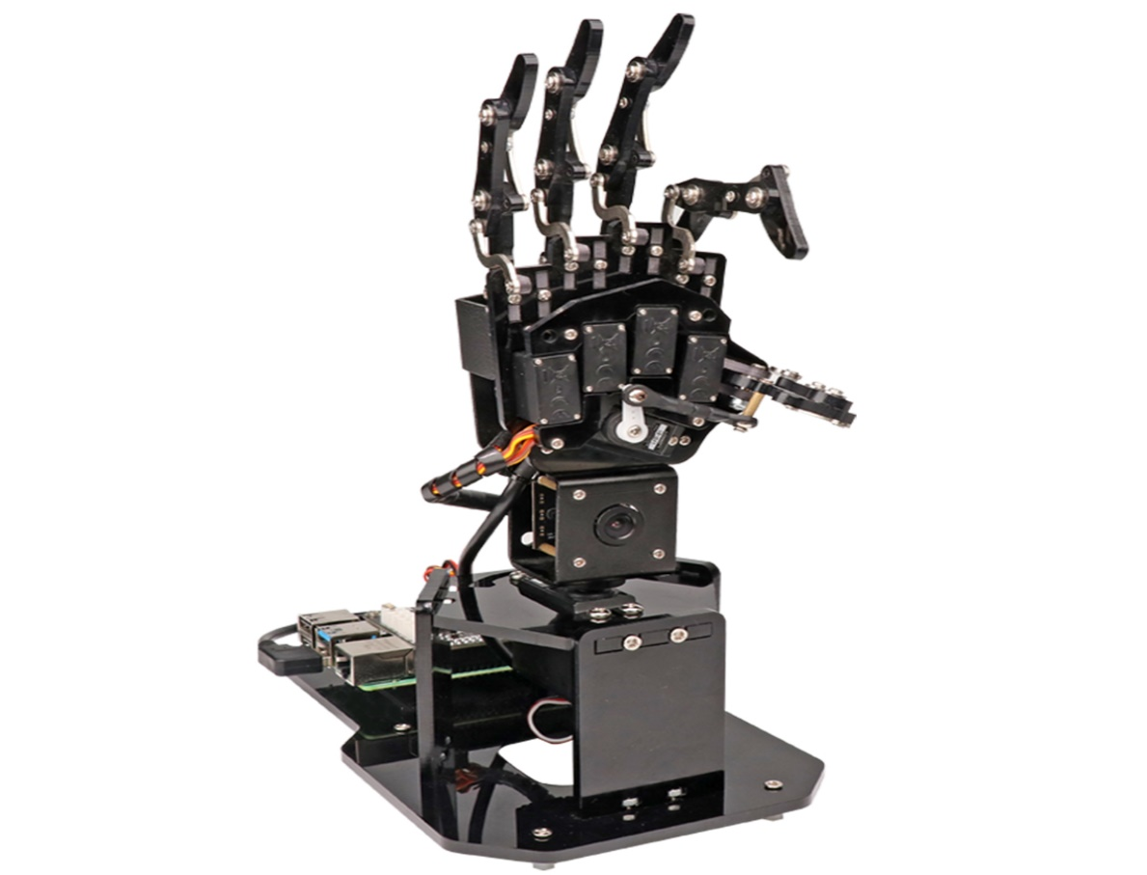

Figure 1:Robotic hand

# **Methodology**

* The first step is to connect the flex sensors to the ATD0 port of the HCS12 microcontroller and calibrate them to ensure accurate readings.
* Next, the PWM signal is generated using the P port of the HCS12, which is used to control the servo motors.
* The servo motors are connected to the robotic hand and are programmed to move in a natural and fluid manner, mimicking the movement of a human hand.
* Finally, a battery is used to power the entire system, ensuring that it can be used without being tethered to an external power source.

To ensure that the robotic hand control system functions properly, several iterations of testing and refinement must be carried out. This involves tweaking the code, adjusting the hardware, and redesigning certain components if necessary. By following this structured methodology, the challenges of developing a robotic hand control system can be overcome, resulting in a functional and accurate system that can be used in a variety of applications.

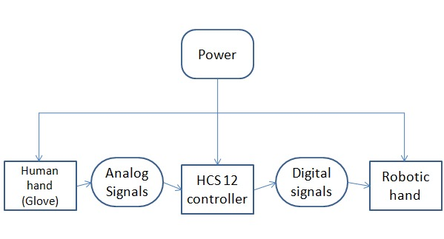

Figure 2:Block diagram of robotic hand controlled

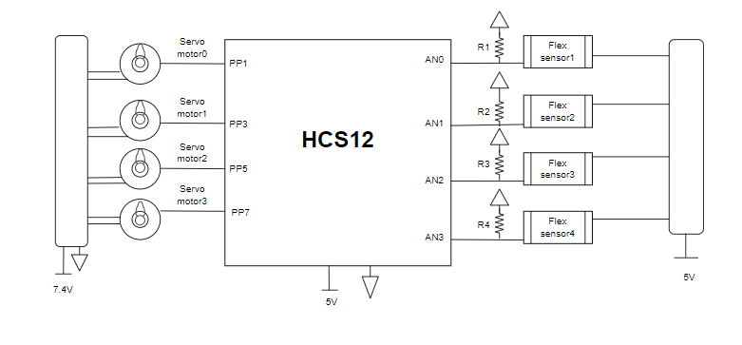

Figure 3: Schematic for controlled robotic hand

# **Required Components**

To design a robotic hand control system using the HCS12 microcontroller, you will need the following requirements:

## **HCS12 Microcontroller:**

Obtain an HCS12 microcontroller board or development kit. Ensure that it supports the necessary features such as GPIO (General Purpose Input/Output) pins, PWM (Pulse Width Modulation) outputs, and analog input capabilities.

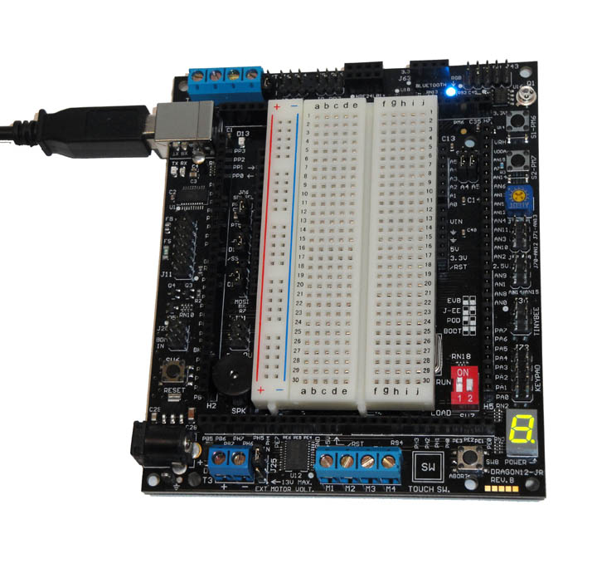

Figure 4:HCS12 microcontroller

## **Motors:**

Select appropriate motors for the robotic hand. The choice of motors will depend on the size and weight requirements of the hand. Consider servo motors that can provide the necessary torque and precision for finger movements.

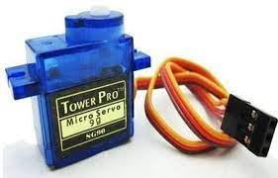

Figure 5:Servo motor

Servo motor works on **PWM (Pulse width modulation)** principle, means its angle of rotation is controlled by the duration of applied pulse to its Control PIN. Basically servo motor is made up of **DC motor which is controlled by a variable resistor (flex sensor) and some gears**. High speed force of DC motor is converted into torque by Gears. The **flex sensor** is connected to the output shaft of the Servo, to calculate the angle and stop the DC motor on the required angle.

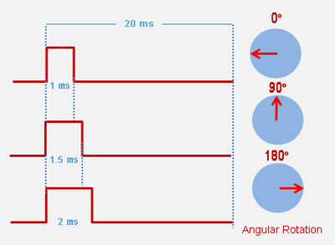

Figure 6:Angular rotation

In this project, four motors were used to move four fingers only because the controller used has only four inputs to create a PWM signal in the case of a 16-bit PWM.

## **Sensors:**

Flexible sensing devices have been considered essentially as changing resistances along area begin with 1inch to 3 inches, as shown in Figure 5. Such apparatuses have been utilized to compute the twisting withinthe handle at the sender part via the altering of the resistors. When the arching slant raises, the resistor valueraises as well the altered resistor has transformed in terms of potential via a potential actuator system alsoprovided to analogue to digital converter (ADC) to get binary transformation [1]. Altering such an amountfortheresistancewillproducevariantoutcomes.Thebendresistancerangeis10kinflat25kinminimumto 125k maximum (depending on bend radius) versus to 300-900 in ADC reading in decimal of range 0-1024[12].Astheflexiblesensingpartsresultinginhonestreadingsjustwhenthebentincertaincoordination commonly towards that theme front for the sensing tools [2]. Considering analogue outcomesfor flexible sensing ports, those had obtained via a factor from that frame containing sensing equipmentshould require for transform within binary for more continue. This situation has almost so often low-costfromeither else sensing part as well as providing better results. Furthermore, the cyphering consideredeasier from alternative animators. Drawbacks were lower precise, obstruction, also have an unpredictablevalueofthesensor.

It is relatively very much cheaper than any other sensors and have good response, also the coding is simple than other robots. The disadvantages less sensitive and more internal and external interference, and also have unpredictable value of sensor [3].

The flex sensor is designed to change its resistance when it is bent. This change in resistance results in a change in voltage output. By using calibration curves and mathematical equations, the voltage output can be correlated with the angle of rotation of the servo motor. This allows for precise control of the movement of the fingers of the robotic hand.

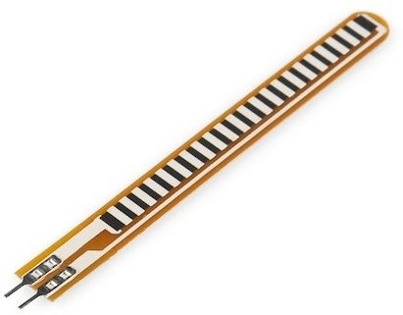

Figure 7:Flex Sensor

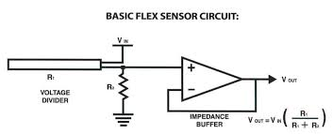

The value of $R_{1}$ in Our project is 50 kΩ and the $V_{In}$ equal to 5V.

$V_{Out}=V_{In}( \frac{R_{1}}{R_{1}+R_{2}})$ = 5 $( \frac{50}{50+R_{2}})$ [V]

## **Power Supply:**

Ensure that you have a stable power supply to operate the HCS12 microcontroller, motor driver, and motors. Consider the voltage and current requirements of the microcontroller, motors, and other components when selecting an appropriate power supply. In our project, we used two batteries with 3.7 volts.

## **Glove:**

The glove of the hand to which the sensor is attached to control the prosthetic hand.

## **Electrical equipment**

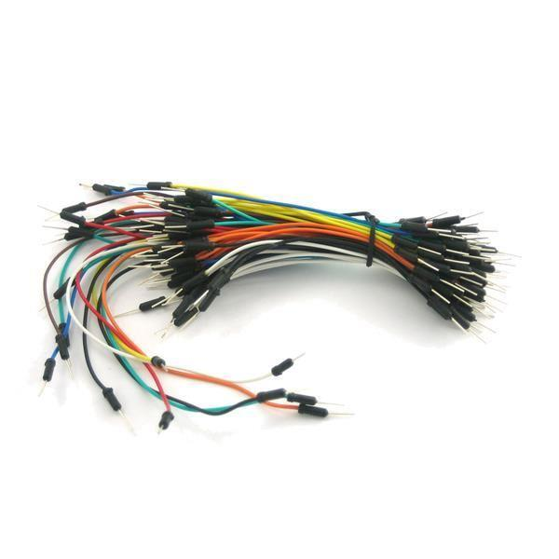

(wires and resistors)

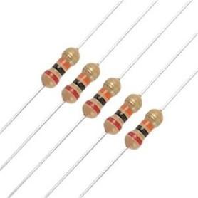

Figure 8:Electrical equipment

## **Wiring and Connections:**

Establish the necessary wiring connections between the HCS12 microcontroller, motor driver, motors, sensors, and power supply. Ensure proper grounding and avoid signal interference.

## **Control Algorithm:**

Develop a control algorithm or set of algorithms to govern the movements of the robotic hand. This may involve tasks such as finger opening/closing, adjusting grip force based on sensor feedback, and integrating user inputs.

# **Programming Environment**

Set up a suitable programming environment for programming the HCS12 microcontroller in the C language. You may need an integrated development environment (IDE) such as CodeWarrior or a compatible compiler to write, compile, and upload the code to the microcontroller.

# **3D Printing Design**

The model was printed in the university laboratory, and we were unable to design a model because that takes a lot of time, so it was chosen using the Internet.

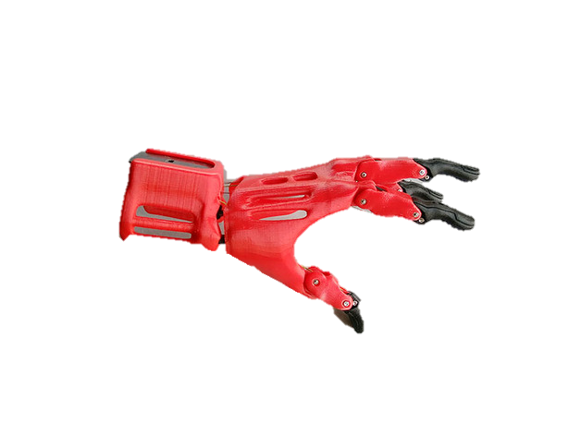

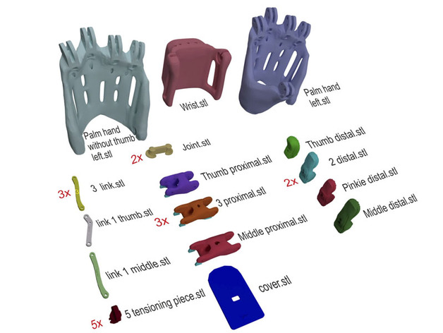

Figure 9:3D Printer module

# **Our Project module**

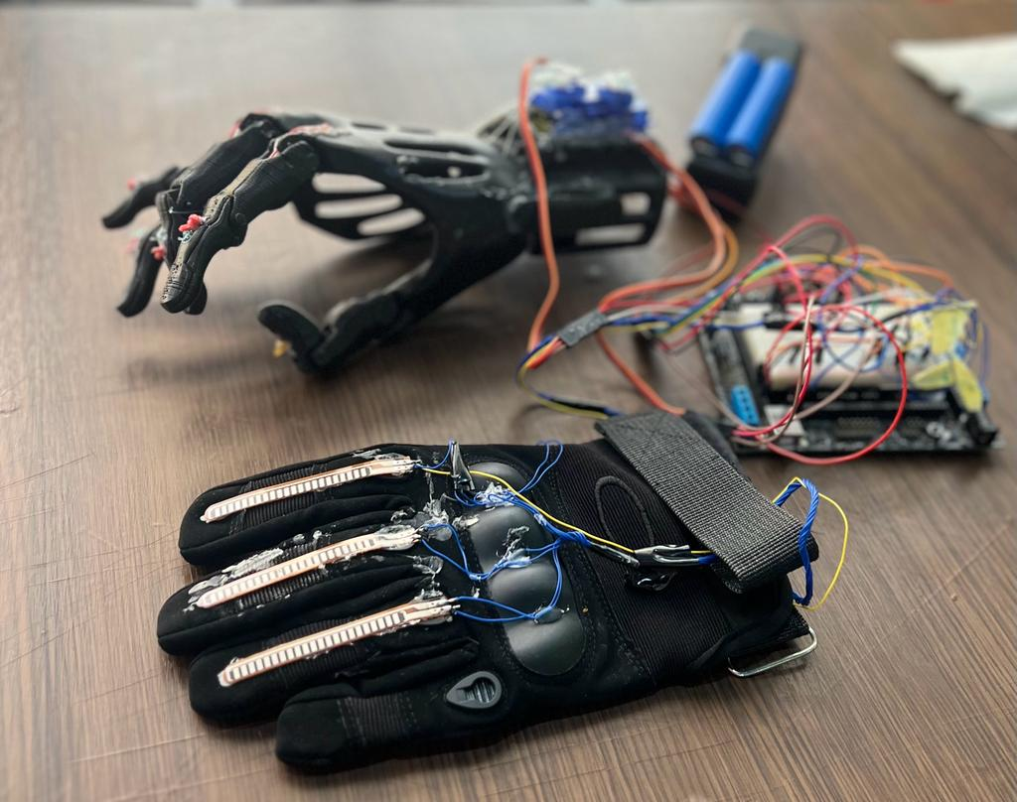

Figure :Robotic hand Project

# **Challenges**

The development of a robotic hand control system using HCS12 poses several challenges. One of the main challenges is ensuring accurate sensor readings, as any deviation can result in imprecise movements. Another challenge is programming the servo motors to move in a natural and fluid manner, mimicking the movement of a human hand. In addition to some challenges during practicing such as complicated wiring connections and three out of four servo motors was replaced two times, At first the motors were found defected then at second time the replaced motors didn’t match the programmed code due to movement angle range was 360° (supposed to be 180°) .These challenges require a thorough understanding of robotics, electronics, and programming, as well as creativity and problem-solving skills.

# **Future work**

There are many possibilities for future work in this area. One such possibility is the development of a more advanced algorithm that can better mimic the natural movements of a human hand. This would require further research into the biomechanics of the human hand and the development of more sophisticated control systems.

Another area where future work could be done is in the use of artificial intelligence to control the robotic hand. By using machine learning algorithms, the robotic hand could learn from its environment and adapt to new situations. This would make it much more versatile and useful in a wide range of applications.

# **Conclusion**

* The use of HCS12 microcontroller, along with the flex sensors and servo motors, allows for precise control over the robotic hand's movements. This opens up possibilities for more advanced applications, such as prosthetics or even space exploration. The future of robotics is bright, and the development of systems like this one will undoubtedly play a significant role in shaping it.
* The design of a control system to operate a robotic hand using an HCS12 microcontroller holds great potential for enhancing the capabilities of robotic systems. The combination of the microcontroller's processing power, integrated peripherals, and software flexibility empowers us to create a control system that facilitates precise, coordinated, and intuitive control of the robotic hand. By leveraging the control system's capabilities, we can unlock new possibilities for robotics applications, ranging from industrial automation and prosthetics to assistive technologies and exploration in challenging environments.

# **References**

[1] Gautami J, Sampada A, Sahil M, Dadhich P 2017, "FLEX SENSOR BASED ROBOTIC ARM CONTROLLER: DEVELOPMENT, " International Journal of Electrical and Electronics Engineers vol. 9 pp. 494-98.

[2] Flex Sensor, [online]. Available: https://arabic.alibaba.com/ (accessed on 15 August 2020).

[3] M. A. doshi, s. j. parekh, d. bhowmick. Wireless Robotic Hand Using Flex Sensors. International Journal of Scientific & Engineering Research, 6(3), 1471-1475, March-2015.

[4]Servo Motor, [Online]. Available: [*https://arabic.alibaba.com/*](https://arabic.alibaba.com/) (accessed on 15 August 2020)